**Office Address**

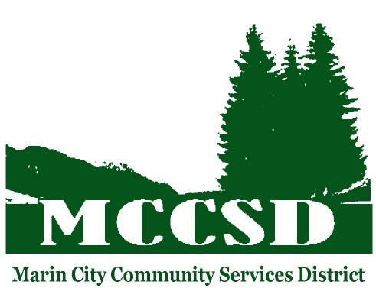640 Drake Avenue

Marin City, CA 94965

**Mailing Address**

P.O. Box 366

Sausalito, CA 94965

**Telephone Number**

(415) 332-1441

**MCCSD**

**Regular Board Meeting Notice and Agenda**

**Wednesday, June 11, 2025 at 5:30 p.m.**

**Location: MCCSD, 640 Drake Avenue**

**Board Members**

**Terrie Harris Green**

**Henry Mims**

**Angela Haynes**

**Kevin Douglas**

**Convene Meeting of the Marin City Community Services District**

1. Call to Order and Roll Call
2. Approval of Agenda
3. Open time for public expression (limit: three minutes per person) (While members of the public are welcome to address the Board, under the Brown Act, Board members may not deliberate or take action on items not on the agenda, and, generally, may only listen.)
4. Board Matters: Directors to provide brief updates.
5. Report/presentation from CalTrans.

**Recommended Action:** Receive presentation and discuss.

1. Update on summer camps.

**Recommended Action:** Discussion only.

g) Budget/Finance update

**Recommended Action:** Discussion only.

h) General Manager’s Report

* George “Rocky” Graham Park Reservation
* Harmony in the Garden Celebration – June 28, 2025
* Juneteenth Celebration – June 21, 2025
* Community BBQ Cook Off August 2025
* MCCSD board Strategic Planning meeting with Omowalle Satterwhite Saturday Aug 9, 2025 at 11 am.

**Adjourn as the Marin City Community Service District**

* If you challenge this Board of Director's action(s) in court, you may be limited to raising only those issues you or someone else raised at the public hearing described in this notice, or in written correspondence delivered to the Secretary of the Board of Directors at or prior to, the public hearing. Any written correspondence delivered to the Secretary of the Board of Directors before the Board of Director’s final action on a matter will become a part of the administrative record.
* **ACCESSIBILITY FOR INDIVIDUALS WITH DISABILITIES**

Upon request, District will provide for written agenda materials in appropriate alternative formats, or disability-related modification or accommodation, including auxiliary aids or services and sign language interpreters, to enable individuals with disabilities to participate in and provide comments at/related to public meetings. Please submit a request, including your name, phone number and/or email address, and a description of the modification, accommodation, auxiliary aid, service, or alternative format requested. Requests will be granted whenever possible and resolved in favor of accessibility.